# A DATA MINING BASED MODEL FOR DETECTION OF FRAUDULENT BEHAVIOUR IN WATER CONSUMPTION

***A Project report submitted to***

***Jawaharlal Nehru Technological University, Kakinada,***

***in the partial fulfillment for the award of the Degree in***

## MASTER OF COMPUTER APPLICATIONS

***Submitted by***

**PADAKANDLA CHENNA KRISHNA RAO**

**(19F95F0016)**

***Under the noble guidance of***

**Dr.K.V.SrinivasaRao, M.Tech,PHd**

**Associate Professor**

****

**PRAKASAM ENGINEERING COLLEGE**

***(An ISO 9001-2008 Certified Institution)***

#### (Affiliated to Jawaharlal Nehru Technological University, Kakinada) O.V.ROAD, KANDUKUR-523105, A.P.

**2019-2021**

**PRAKASAM ENGINEERING COLLEGE**

***(An ISO 9001-2008 Certified Institution)***

**(Affiliated to Jawaharlal Nehru Technological University, Kakinada) O.V.ROAD, KANDUKUR-523105, A.P.**



## DEPARTMENT OF

**MASTER OF COMPUTER APPLICATIONS BONAFIDE CERTIFICATE**

*This is to certify that the project entitled* **“A DATA MINING BASED MODEL FOR DETECTION OF FRAUDULENT BEHAVIOUR IN WATER CONSUMPTION”** *is a bonafide work of* **PADAKANDLA CHENNA KRISHNA RAO (19F95F0016)** *in the partial fulfillment of the requirement for the award of the degree in* **MASTER OF COMPUTER APPLICATIONS** *for the academic year 2019-2021. This work is done under my supervision and guidance.*

## Signature of the GUIDE Signature of the HOD

#### Dr.K.V.SrinivasaRao, Mr. M. M. RAYUDU,

#### M.Tech,PHd. M.Tech, (Ph.D)

**Signature of the External Examiner**

**DECLARATION**

I do here by declare that the project work entitled **“A DATA MINING BASED MODEL FOR DETECTION OF FRAUDULENT BEHAVIOUR IN WATER CONSUMPTION”** is a genuine work carried out by me under the guidance of Dr. **K.V.SrinivasaRao,M.Tech,PHd.** in partial fulfillment for the award of the degree of **“Master of Computer Applications”** of **Jawaharlal Nehru Technological University, Kakinada.**

#### PADAKANDLA CHENNA KRISHNA RAO

#### (19F95F0016)

**ACKNOWLEDGEMENT**

I feel to render my thankful acknowledgement to the following distinguished personalities, who stretched their helping hand to us, in completing our project work.

I am very grateful and my sincere thanks to our secretary & correspondent **Dr.K.RAMAIAH** of **PRAKASAM ENGINEERING COLLEGE** for giving this opportunity.

I hereby, express my regards and extend my gratitude to our PRINCIPAL, **Dr.M.LAKSHMAN RAO**, for giving this opportunity to do the thesis as a part of our course.

I express my deep sense of gratitude to **Mr.M.M.RAYUDU, M.Tech(Ph.d),** Head of the Department, **Department of MCA** for having shown keen interest at every stage of development of our thesis and guiding us in every aspect.

And I am thankful to my Internal **Dr.K.V.SrinivasaRao,M.Tech,PHd** who has channeled my thoughts and timely suggestions.

I would also like to thank all our Faculties in Prakasam Engineering College for their constant encouragement and for being a great group of knowledgeable and cooperative people to work with.

## 

## PADAKANDLA CHENNA KRISHNA RAO

## (19F95F0016)

**TABLE OF CONTENTS**

**CHAPTER PAGE NO**

LIST OF FIGURES

ABSTRACT 1

1. INTRODUCTION 2-3

2. LITERATURE SURVEY 4-6

2.1Fast non technical loses identification through4

Optimum path forest

2.2 Data mining techniques for the detection of fraudulent 4

Financial statements

2.3 Detecting credit card fraud by decision trees and support 4

Vector machines

2.4 A data mining based system for credit card fraud detection 5

In e-tail decision support system

2.5 Detection of abnormalities and electricity theft using 5-6

genetic support vector machines

3. SYSYEM ANALYSIS 7-10

3.1 Existing systems 7

3.2 proposed system 7

3.3 system requirement 8

i)Hardware requirements

ii)Software requirements

3.4 System study 9-10

I)Feasibility Study

i)Economical feasibility 9

ii)Technical feasibility 9

iii)Social feasibility 10

4. SYSTEM DESIGN 11-16

4.1 System Architecture 11

4.2 UML Diagrams 11-15

4.3 Implementation modules 15-16

5. SOFTWARE ENVIRONMENT 17-37

6. SYSTEM TESTING 38-40

6.1 Unit Testing 38

6.2 Integration Testing 38

6.3 Functional Testing 38

6.4 System Testing 39

6.5 White box Testing 39

* 1. Black box Testing 39

6.7 Acceptance Testing 39

7. SCREEN SHOTS 40-45

8. CONCLUSION 46-47

9.REFERENCES 48-49

**LIST OF FIGURES**

|  |  |  |
| --- | --- | --- |
| **Figure Number** | **Figure Name** | **Page Number** |
| **4.1** | **System architecture** | **11** |
| **4.2.1** | **Use Case Diagram** | **12** |
| **4.2.2** | **Class Diagram** | **13** |
| **4.2.3** | **Sequence Diagram** | **14** |
| **4.2.4** | **Collaboration Diagram** | **15** |

**ABSTRACT**

Fraudulent behavior in drinking water consumption is a significant problem facing water supplying companies and agencies. This behavior results in a massive loss of income and forms the highest percentage of non-technical loss. Finding efficient measurements for detecting fraudulent activities has been an active research area in recent years. Intelligent data mining techniques can help water supplying companies to detect these fraudulent activities to reduce such losses. This research explores the use of two classification techniques (SVM and KNN) to detect suspicious fraud water customers. The main motivation of this research is to assist Yarmouk Water Company (YWC) in Irbid city of Jordan to overcome its profit loss. The SVM based approach uses customer load profile attributes to expose abnormal behavior that is known to be correlated with non-technical loss activities. The data has been collected from the historical data of the company billing system. The accuracy of the generated model hit a rate of over 74% which is better than the current manual prediction procedures taken by the YWC. To deploy the model, a decision tool has been built using the generated model. The system will help the company to predict suspicious water customers to be inspected on site.

**1.INTRODUCTION**

Water is an essential element for the uses of households, industry, and agriculture. Jordan, as several other countries in the world, suffers from water scarcity, which poses a threat that would affect all sectors that depend on the availability of water for the sustainability of activities for their development and prosperity [1]. According to Jordan ministry of water and irrigation, this issue always has been one of the biggest barriers to the economic growth and development for Jordan. This crisis situation has been aggravated by a population increase that has doubled in the last two decades. Efforts of the ministry of Water and irrigation to improve water and sanitation services are faced by managerial, technical and financial determinants and the limited amount of renewable freshwater resources [2]. To address these challenges, Jordan ministry of water and irrigation as in many other countries is striving, through the adoption of a long-term plan, to improve services provided to citizens through restructuring and rehabilitation of networks, reducing the non-revenue water rates, providing new sources and maximizing the efficient use of available sources. At the same time, the Ministry continues its efforts to regulate the water usage and to detect the loss of supplied water [2]. Water supplying companies incur significant losses due to fraud operations in water consumption. The customers who tamper their water meter readings to avoid or reduce billing amount is called a fraud customer. In practice, there are two types of water loss: the first is called technical loss (TL) which is related to problems in the production system, the transmission of water through the network (i.e., leakage), and the network washout. The second type is called the non-technical loss (NTL) which is the amount of delivered water to customers but not billed, resulting in loss of revenue [3]. The management of the Yarmouk Water Company (Jordan) has a significant concern to reduce its profit losses, especially those derived from NTLs, which are estimated over 35% in the whole service area in the year 2012. One major part of NLT is customer’s fraudulent activities; the commercial department manages the detection processes with the absence of an intelligent computerized system where the current process is costly, not effective nor efficient. NTL is a serious problem facing Yarmouk Water Company (YWC). In 2012 the NTL reached over 35%, ranging from 31% to 61 according to districts, which results in a loss of 13 million dollars per year. Currently, YWC follows random inspections for customers, the proposed model in this paper provides a valuable tool to help YWC teams to detect theft customers, which will reduce the NTL and raise profit. Literature has abundant research for Non-Technical Loss (NTL) in electricity fraud detection, but rare researches have been conducted for the water consumption sector. This paper focuses on customer’s historical data which are selected from the YWC billing system. The main objective of this work is to use some well-known data mining techniques named Support Vector Machines (SVM) and K-Nearest Neighbor (KNN) to build a suitable model to detect suspicious fraudulent customers, depending on their historical water metered consumptions.

**2.LITERATURE SURVEY**

* 1. **Fast non-technical losses identification through optimum-path forest**

**AUTHORS:**  **C. Ramos , A. Souza , J. Papa and A. Falcao,**

**ABSTRACT:** Fraud detection in energy systems by illegal consumers is the most actively pursued study in non-technical losses by electric power companies. Commonly used supervised pattern recognition techniques, such as artificial neural networks and support vector machines have been applied for automatic commercial frauds identification, however they suffer from slow convergence and high computational burden. We introduced here the optimum-path forest classifier for a fast non-technical losses recognition, which has been demonstrated to be superior than neural networks and similar to Support vector machines, but much faster. Comparisons among these classifiers are also presented.

**2.2** **Data mining techniques for the detection of fraudulent financial statements**

**AUTHORS:**  **E. Kirkos, C. Spathis and Y. Manolopoulos,**

**ABSTRACT:** This paper explores the effectiveness of Data Mining (DM) classification techniques in detecting firms that issue fraudulent financial statements (FFS) and deals with the identification of factors associated to FFS. In accomplishing the task of management fraud detection, auditors could be facilitated in their work by using Data Mining techniques. This study investigates the usefulness of Decision Trees, Neural Networks and Bayesian Belief Networks in the identification of fraudulent financial statements. The input vector is composed of ratios derived from financial statements. The three models are compared in terms of their performances.

**2.3 Detecting credit card fraud by decision trees and support vector machines**

**AUTHORS:**  **Y. Sahin and E. Duman**

**ABSTRACT:** With the developments in the Information Technology and improvements in the communication channels, fraud is spreading all over the world, resulting in huge financial losses. Though fraud prevention mechanisms such as CHIP&PIN are developed, these mechanisms do not prevent the most common fraud types such as fraudulent credit card usages over virtual POS terminals or mail orders. As a result, fraud detection is the essential tool and probably the best way to stop such fraud types. In this study, classification models based on decision trees and support vector machines (SVM) are developed and applied on credit card fraud detection problem. This study is one of the firsts to compare the performance of SVM and decision tree methods in credit card fraud detection with a real data set.

# 2.4 A data mining based system for credit-card fraud detection in e-tail decision support system

**AUTHORS:**  **N. Carneiro, G. Figueira and Costa M.,**

**ABSTRACT:** Credit-card fraud leads to billions of dollars in losses for online merchants. With the development of machine learning algorithms, researchers have been finding increasingly sophisticated ways to detect fraud, but practical implementations are rarely reported. We describe the development and deployment of a fraud detection system in a large e-tail merchant. The paper explores the combination of manual and automatic classification, gives insights into the complete development process and compares different machine learning methods. The paper can thus help researchers and practitioners to design and implement data mining based systems for fraud detection or similar problems. This project has contributed not only with an automatic system, but also with insights to the fraud analysts for improving their manual revision process, which resulted in an overall superior performance.

**2.5**  **Detection of abnormalities and electricity theft using genetic support vector machines**

**AUTHORS:**  **J. Nagi, K. Yap, S. Tiong, S. Ahmed and A. Mohammad**

**ABSTRACT:** Efficient methods for detecting electricity fraud has been an active research area in recent years. This paper presents a hybrid approach towards non-technical loss (NTL) analysis for electric utilities using genetic algorithm (GA) and support vector machine (SVM). The main motivation of this study is to assist Tenaga Nasional Berhad (TNB) in Malaysia to reduce its NTLs in the distribution sector. This hybrid GA-SVM model preselects suspected customers to be inspected onsite for fraud based on abnormal consumption behavior. The proposed approach uses customer load profile information to expose abnormal behavior that is known to be highly correlated with NTL activities. GA provides an increased convergence and globally optimized SVM hyper-parameters using a combination of random and prepopulated genomes. The result of the fraud detection model yields classified classes that are used to shortlist potential fraud suspects for onsite inspection. Simulation results prove the proposed method is more effective compared to the current actions taken by TNB in order to reduce NTL activities.

**3.SYSTEM ANALYSIS**

**3.1 EXISTING SYSTEM:**

Literature has abundant research for Non-Technical Loss (NTL) in electricity fraud detection, but rare researches have been conducted for the water consumption sector.Water supplying companies incur significant losses due to fraud operations in water consumption. The customers who tamper their water meter readings to avoid or reduce billing amount is called a fraud customer. In practice, there are two types of water loss: the first is called technical loss (TL) which is related to problems in the production system, the transmission of water through the network (i.e., leakage), and the network washout. The second type is called the non-technical loss (NTL) which is the amount of delivered water to customers but not billed, resulting in loss of revenue.To address these challenges, Jordan ministry of water and irrigation as in many other countries is striving, through the adoption of a long-term plan, to improve services provided tocitizens through restructuring and rehabilitation of networks, reducing the non-revenue water rates, providing new sources and maximizing the efficient use of available sources. At the same time, the Ministry continues its efforts to regulate the water usage and to detect the loss of supplied water.

**3.2.PROPOSED SYSTEM:**

This paper focuses on customer’s historical data which are selected from the YWC billing system. The main objective of this work is to use some well-known data mining techniques named Support Vector Machines (SVM) and K-Nearest Neighbor (KNN) to build a suitable model to detect suspicious fraudulent customers, depending on their historical water metered consumptions.The CRISP-DM (Cross Industry Standard Process for Data Mining) was adopted to conduct this research. The CRISPDM is an industry standard data mining methodology developed by four Companies; NCR systems engineering, DaimlerChrysler AG, SPSS Inc. and OHRA. The CRISP-DM model consists of business understanding, data understanding, data preparation, model building, model evaluation and model deployment.To extract the fraud customers’ profile, a new table is created containing the client's number, the water consumption, and a new attribute for fraud class. This attribute is filled with a value of ‘YES’. Another table for the normal clients is created, and the fraud class attribute is filled with the value “NO”. The two tables are then consolidated into one table containing the customer ID, consumption profile, and fraud class attributes. To filter the data, some preprocessing operations were performed such as Eliminate redundancy, Eliminate customers having zeroconsumption through the entire period, Eliminate new clients who are not present during the whole targeted period, and Eliminate customers having null consumption values. Filtering the data resulted in a reduced original dataset of the non-fraud customer to 16114 record and the fraud customers to 647 records.

**3.3. SYSTEM REQUIREMENTS:**

**HARDWARE REQUIREMENTS:**

* System : Pentium IV 2.4 GHz.
* Hard Disk : 40 GB.
* Floppy Drive : 1.44 Mb.
* Monitor : 15 VGA Colour.
* Mouse : Logitech.
* Ram : 512 Mb.

**SOFTWARE REQUIREMENTS:**

* **Operating System:** Windows
* **Coding Language**: Python 3.7

**3.4 SYSTEM STUDY**

**FEASIBILITY STUDY**

The feasibility of the project is analyzed in this phase and business proposal is put forth with a very general plan for the project and some cost estimates. During system analysis the feasibility study of the proposed system is to be carried out. This is to ensure that the proposed system is not a burden to the company. For feasibility analysis, some understanding of the major requirements for the system is essential.

Three key considerations involved in the feasibility analysis are

* ECONOMICAL FEASIBILITY
* TECHNICAL FEASIBILITY
* SOCIAL FEASIBILITY

**ECONOMICAL FEASIBILITY**

This study is carried out to check the economic impact that the system will have on the organization. The amount of fund that the company can pour into the research and development of the system is limited. The expenditures must be justified. Thus the developed system as well within the budget and this was achieved because most of the technologies used are freely available. Only the customized products had to be purchased.

### **TECHNICAL FEASIBILITY**

This study is carried out to check the technical feasibility, that is, the technical requirements of the system. Any system developed must not have a high demand on the available technical resources. This will lead to high demands on the available technical resources. This will lead to high demands being placed on the client. The developed system must have a modest requirement, as only minimal or null changes are required for implementing this system.

**SOCIAL FEASIBILITY**

The aspect of study is to check the level of acceptance of the system by the user. This includes the process of training the user to use the system efficiently. The user must not feel threatened by the system, instead must accept it as a necessity. The level of acceptance by the users solely depends on the methods that are employed to educate the user about the system and to make him familiar with it. His level of confidence must be raised so that he is also able to make some constructive criticism, which is welcomed, as he is the final user of the system.

**4.SYSTEM DESIGN**

**4.1 SYSTEM ARCHITECTURE:**

The main steps of this phase are illustrated in Figure 1. The consumption table of the historical customers’ data contains around 16 million records for 109 thousand customers. It includes the consumptions for the interval from 1990 to the current time. The customers’ consumption records that are related to Qasabat Irbid ROU are around 1.5 million consumption records for around 90 thousand customers. The consumption data for the customers are stored in a vertical format as shown in Figure

**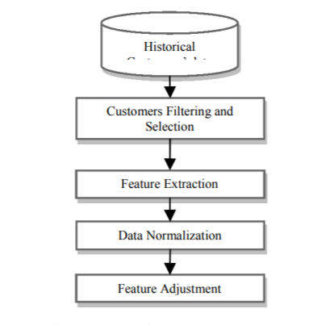**

**4.2 UML DIAGRAMS**

UML stands for Unified Modeling Language. UML is a standardized general-purpose modeling language in the field of object-oriented software engineering. The standard is managed, and was created by, the Object Management Group.

The goal is for UML to become a common language for creating models of object oriented computer software. In its current form UML is comprised of two major components: a Meta-model and a notation. In the future, some form of method or process may also be added to; or associated with, UML.

The Unified Modeling Language is a standard language for specifying, Visualization, Constructing and documenting the artifacts of software system, as well as for business modeling and other non-software systems.

The UML represents a collection of best engineering practices that have proven successful in the modeling of large and complex systems.

The UML is a very important part of developing objects oriented software and the software development process. The UML uses mostly graphical notations to express the design of software projects.

**GOALS:**

The Primary goals in the design of the UML are as follows:

1. Provide users a ready-to-use, expressive visual modeling Language so that they can develop and exchange meaningful models.
2. Provide extendibility and specialization mechanisms to extend the core concepts.
3. Be independent of particular programming languages and development process.
4. Provide a formal basis for understanding the modeling language.
5. Encourage the growth of OO tools market.
6. Support higher level development concepts such as collaborations, frameworks, patterns and components.
7. Integrate best practices.

**USE CASE DIAGRAM:**

A use case diagram in the Unified Modeling Language (UML) is a type of behavioral diagram defined by and created from a Use-case analysis. Its purpose is to present a graphical overview of the functionality provided by a system in terms of actors, their goals (represented as use cases), and any dependencies between those use cases. The main purpose of a use case diagram is to show what system functions are performed for which actor. Roles of the actors in the system can be depicted.



**CLASS DIAGRAM:**

In software engineering, a class diagram in the Unified Modeling Language (UML) is a type of static structure diagram that describes the structure of a system by showing the system's classes, their attributes, operations (or methods), and the relationships among the classes. It explains which class contains information.



**SEQUENCE DIAGRAM:**

A sequence diagram in Unified Modeling Language (UML) is a kind of interaction diagram that shows how processes operate with one another and in what order. It is a construct of a Message Sequence Chart. Sequence diagrams are sometimes called event diagrams, event scenarios, and timing diagrams.



**Collaboration diagram:**

A collaboration diagram groups together the interactions between different objects. The interactions are listed as numbered interactions that help to trace the sequence of the interactions. The collaboration diagram helps to identify all the possible interactions that each object has with other objects.



**4.3 IMPLEMENTATION:**

**MODULES:**

**USER**

In this module user can able to do these operations

Upload Water Consumption Dataset

Preprocess Dataset

Run SVM Algorithm

Run KNN Algorithm

Accuracy Comparison Graph

Predict Fraud using Test Data

Close Application

**ALGORITHM**

**SUPPORT VECTOR MACHINE**

“Support Vector Machine” (SVM) is a supervised machine learning algorithm which can be used for both classification and regression challenges. However, it is mostly used in classification problems. In this algorithm, we plot each data item as a point in n-dimensional space (where n is number of features you have) with the value of each feature being the value of a particular coordinate. Then, we perform classification by finding the hyper-plane that differentiate the two classes very well (look at the below snapshot).Support Vectors are simply the co-ordinates of individual observation. Support Vector Machine is a frontier which best segregates the two classes (hyper-plane/ line).More formally, a support vector machine constructs a hyper plane or set of hyper planes in a high- or infinite-dimensional space, which can be used for classification, regression, or other tasks like outliers detection. Intuitively, a good separation is achieved by the hyper plane that has the largest distance to the nearest training-data point of any class (so-called functional margin), since in general the larger the margin the lower the generalization error of the classifier.Whereas the original problem may be stated in a finite dimensional space, it often happens that the sets to discriminate are not linearly separable in that space. For this reason, it was proposed that the original finite-dimensional space be mapped into a much higher-dimensional space, presumably making the separation easier in that space.

**5.SOFTWARE ENVIRONMENT**

# What is Python :-

Below are some facts about Python.

Python is currently the most widely used multi-purpose, high-level programming language.

Python allows programming in Object-Oriented and Procedural paradigms. Python programs generally are smaller than other programming languages like Java.

Programmers have to type relatively less and indentation requirement of the language, makes them readable all the time.

Python language is being used by almost all tech-giant companies like – Google, Amazon, Facebook, Instagram, Dropbox, Uber… etc.

The biggest strength of Python is huge collection of standard library which can be used for the following –

* + [Machine Learning](https://www.geeksforgeeks.org/machine-learning/)
  + GUI Applications (like Kivy, Tkinter, PyQt etc. )
  + Web frameworks like Django (used by YouTube, Instagram, Dropbox)
  + Image processing (like Opencv, Pillow)
  + Web scraping (like Scrapy, BeautifulSoup, Selenium)
  + Test frameworks
  + Multimedia

### Advantages of Python :-

Let’s see how Python dominates over other languages.

#### 1. Extensive Libraries

Python downloads with an extensive library and it contain code for various purposes like regular expressions, documentation-generation, unit-testing, web browsers, threading, databases, CGI, email, image manipulation, and more. So, we don’t have to write the complete code for that manually.

#### 2. Extensible

As we have seen earlier, Python can be**extended to other languages**. You can write some of your code in languages like C++ or C. This comes in handy, especially in projects.

#### 3. Embeddable

Complimentary to extensibility, Python is embeddable as well. You can put your Python code in your source code of a different language, like C++. This lets us add **scripting capabilities**to our code in the other language.

#### 4. Improved Productivity

The language’s simplicity and extensive libraries render programmers**more productive** than languages like Java and C++ do. Also, the fact that you need to write less and get more things done.

#### 5. IOT Opportunities

Since Python forms the basis of new platforms like Raspberry Pi, it finds the future bright for the Internet Of Things. This is a way to connect the language with the real world.

#### 6. Simple and Easy

When working with Java, you may have to create a class to print **‘Hello World’**. But in Python, just a print statement will do. It is also quite **easy to learn, understand,** and**code.** This is why when people pick up Python, they have a hard time adjusting to other more verbose languages like Java.

#### 7. Readable

Because it is not such a verbose language, reading Python is much like reading English. This is the reason why it is so easy to learn, understand, and code. It also does not need curly braces to define blocks, and **indentation is mandatory.** This further aids the readability of the code.

#### 8. Object-Oriented

This language supports both the **procedural and object-oriented**programming paradigms. While functions help us with code reusability, classes and objects let us model the real world. A class allows the **encapsulation of data** and functions into one.

#### 9. Free and Open-Source

Like we said earlier, Python is **freely available.** But not only can you[**download Python**](https://data-flair.training/blogs/install-python-windows/) for free, but you can also download its source code, make changes to it, and even distribute it. It downloads with an extensive collection of libraries to help you with your tasks.

#### 10. Portable

When you code your project in a language like C++, you may need to make some changes to it if you want to run it on another platform. But it isn’t the same with Python. Here, you need to**code only once**, and you can run it anywhere. This is called **Write Once Run Anywhere (WORA)**. However, you need to be careful enough not to include any system-dependent features.

#### 11. Interpreted

Lastly, we will say that it is an interpreted language. Since statements are executed one by one, **debugging is easier** than in compiled languages.

Any doubts till now in the advantages of Python? Mention in the comment section.

### **Advantages of Python Over Other Languages**

#### 1. Less Coding

Almost all of the tasks done in Python requires less coding when the same task is done in other languages. Python also has an awesome standard library support, so you don’t have to search for any third-party libraries to get your job done. This is the reason that many people suggest learning Python to beginners.

#### 2. Affordable

Python is free therefore individuals, small companies or big organizations can leverage the free available resources to build applications. Python is popular and widely used so it gives you better community support.

**The 2019 Github annual survey showed us that Python has overtaken Java in the most popular programming language category.**

#### 3. Python is for Everyone

Python code can run on any machine whether it is Linux, Mac or Windows. Programmers need to learn different languages for different jobs but with Python, you can professionally build web apps, perform data analysis and [**machine learning**](https://data-flair.training/blogs/machine-learning-tutorials-home/), automate things, do web scraping and also build games and powerful visualizations. It is an all-rounder programming language.

### **Disadvantages of Python**

So far, we’ve seen why Python is a great choice for your project. But if you choose it, you should be aware of its consequences as well. Let’s now see the downsides of choosing Python over another language.

#### 1. Speed Limitations

We have seen that Python code is executed line by line. But since [Python](https://www.python.org/) is interpreted, it often results in **slow execution**. This, however, isn’t a problem unless speed is a focal point for the project. In other words, unless high speed is a requirement, the benefits offered by Python are enough to distract us from its speed limitations.

#### 2. Weak in Mobile Computing and Browsers

While it serves as an excellent server-side language, Python is much rarely seen on the **client-side**. Besides that, it is rarely ever used to implement smartphone-based applications. One such application is called **Carbonnelle**.

The reason it is not so famous despite the existence of Brython is that it isn’t that secure.

#### 3. Design Restrictions

As you know, Python is **dynamically-typed**. This means that you don’t need to declare the type of variable while writing the code. It uses **duck-typing**. But wait, what’s that? Well, it just means that if it looks like a duck, it must be a duck. While this is easy on the programmers during coding, it can**raise run-time errors**.

#### 4. Underdeveloped Database Access Layers

Compared to more widely used technologies like **JDBC (Java DataBase Connectivity)** and **ODBC (Open DataBase Connectivity)**, Python’s database access layers are a bit underdeveloped. Consequently, it is less often applied in huge enterprises.

#### 5. Simple

No, we’re not kidding. Python’s simplicity can indeed be a problem. Take my example. I don’t do Java, I’m more of a Python person. To me, its syntax is so simple that the verbosity of Java code seems unnecessary.

This was all about the Advantages and Disadvantages of Python Programming Language.

**History of Python : -**

What do the alphabet and the programming language Python have in common? Right, both start with ABC. If we are talking about ABC in the Python context, it's clear that the programming language ABC is meant. ABC is a general-purpose programming language and programming environment, which had been developed in the Netherlands, Amsterdam, at the CWI (Centrum Wiskunde &Informatica). The greatest achievement of ABC was to influence the design of Python.Python was conceptualized in the late 1980s. Guido van Rossum worked that time in a project at the CWI, called Amoeba, a distributed operating system. In an interview with Bill Venners1, Guido van Rossum said: "In the early 1980s, I worked as an implementer on a team building a language called ABC at Centrum voor Wiskunde en Informatica (CWI). I don't know how well people know ABC's influence on Python. I try to mention ABC's influence because I'm indebted to everything I learned during that project and to the people who worked on it."Later on in the same Interview, Guido van Rossum continued: "I remembered all my experience and some of my frustration with ABC. I decided to try to design a simple scripting language that possessed some of ABC's better properties, but without its problems. So I started typing. I created a simple virtual machine, a simple parser, and a simple runtime. I made my own version of the various ABC parts that I liked. I created a basic syntax, used indentation for statement grouping instead of curly braces or begin-end blocks, and developed a small number of powerful data types: a hash table (or dictionary, as we call it), a list, strings, and numbers."

**What is Machine Learning : -**

Before we take a look at the details of various machine learning methods, let's start by looking at what machine learning is, and what it isn't. Machine learning is often categorized as a subfield of artificial intelligence, but I find that categorization can often be misleading at first brush. The study of machine learning certainly arose from research in this context, but in the data science application of machine learning methods, it's more helpful to think of machine learning as a means of building models of data.

Fundamentally, machine learning involves building mathematical models to help understand data. "Learning" enters the fray when we give these models tunable parameters that can be adapted to observed data; in this way the program can be considered to be "learning" from the data. Once these models have been fit to previously seen data, they can be used to predict and understand aspects of newly observed data. I'll leave to the reader the more philosophical digression regarding the extent to which this type of mathematical, model-based "learning" is similar to the "learning" exhibited by the human brain.Understanding the problem setting in machine learning is essential to using these tools effectively, and so we will start with some broad categorizations of the types of approaches we'll discuss here.

**Categories Of Machine Leaning :-**

At the most fundamental level, machine learning can be categorized into two main types: supervised learning and unsupervised learning.

Supervised learning involves somehow modeling the relationship between measured features of data and some label associated with the data; once this model is determined, it can be used to apply labels to new, unknown data. This is further subdivided into classification tasks and regression tasks: in classification, the labels are discrete categories, while in regression, the labels are continuous quantities. We will see examples of both types of supervised learning in the following section.

Unsupervised learning involves modeling the features of a dataset without reference to any label, and is often described as "letting the dataset speak for itself." These models include tasks such as clustering and dimensionality reduction. Clustering algorithms identify distinct groups of data, while dimensionality reduction algorithms search for more succinct representations of the data. We will see examples of both types of unsupervised learning in the following section.

## Need for Machine Learning

Human beings, at this moment, are the most intelligent and advanced species on earth because they can think, evaluate and solve complex problems. On the other side, AI is still in its initial stage and haven’t surpassed human intelligence in many aspects. Then the question is that what is the need to make machine learn? The most suitable reason for doing this is, “to make decisions, based on data, with efficiency and scale”.

Lately, organizations are investing heavily in newer technologies like Artificial Intelligence, Machine Learning and Deep Learning to get the key information from data to perform several real-world tasks and solve problems. We can call it data-driven decisions taken by machines, particularly to automate the process. These data-driven decisions can be used, instead of using programing logic, in the problems that cannot be programmed inherently. The fact is that we can’t do without human intelligence, but other aspect is that we all need to solve real-world problems with efficiency at a huge scale. That is why the need for machine learning arises.

## Challenges in Machines Learning :-

While Machine Learning is rapidly evolving, making significant strides with cybersecurity and autonomous cars, this segment of AI as whole still has a long way to go. The reason behind is that ML has not been able to overcome number of challenges. The challenges that ML is facing currently are −

**Quality of data** − Having good-quality data for ML algorithms is one of the biggest challenges. Use of low-quality data leads to the problems related to data preprocessing and feature extraction.

**Time-Consuming task** − Another challenge faced by ML models is the consumption of time especially for data acquisition, feature extraction and retrieval.

**Lack of specialist persons** − As ML technology is still in its infancy stage, availability of expert resources is a tough job.

**No clear objective for formulating business problems** − Having no clear objective and well-defined goal for business problems is another key challenge for ML because this technology is not that mature yet.

**Issue of overfitting & underfitting** − If the model is overfitting or underfitting, it cannot be represented well for the problem.

**Curse of dimensionality** − Another challenge ML model faces is too many features of data points. This can be a real hindrance.

**Difficulty in deployment** − Complexity of the ML model makes it quite difficult to be deployed in real life.

## Applications of Machines Learning :-

Machine Learning is the most rapidly growing technology and according to researchers we are in the golden year of AI and ML. It is used to solve many real-world complex problems which cannot be solved with traditional approach. Following are some real-world applications of ML −

* Emotion analysis
* Sentiment analysis
* Error detection and prevention
* Weather forecasting and prediction
* Stock market analysis and forecasting
* Speech synthesis
* Speech recognition
* Customer segmentation
* Object recognition
* Fraud detection
* Fraud prevention
* Recommendation of products to customer in online shopping

# How to Start Learning Machine Learning?

Arthur Samuel coined the term **“Machine Learning”** in 1959 and defined it as a **“Field of study that gives computers the capability to learn without being explicitly programmed”.**

And that was the beginning of Machine Learning! In modern times, Machine Learning is one of the most popular (if not the most!) career choices. According to [Indeed](http://blog.indeed.com/2019/03/14/best-jobs-2019/), Machine Learning Engineer Is The Best Job of 2019 with a 344% growth and an average base salary of **$146,085** per year.

But there is still a lot of doubt about what exactly is Machine Learning and how to start learning it? So this article deals with the Basics of Machine Learning and also the path you can follow to eventually become a full-fledged Machine Learning Engineer. Now let’s get started!!!

### **How to start learning ML?**

This is a rough roadmap you can follow on your way to becoming an insanely talented Machine Learning Engineer. Of course, you can always modify the steps according to your needs to reach your desired end-goal!

### Step 1 – Understand the Prerequisites

In case you are a genius, you could start ML directly but normally, there are some prerequisites that you need to know which include Linear Algebra, Multivariate Calculus, Statistics, and Python. And if you don’t know these, never fear! You don’t need a Ph.D. degree in these topics to get started but you do need a basic understanding.

#### (a) Learn Linear Algebra and Multivariate Calculus

Both Linear Algebra and Multivariate Calculus are important in Machine Learning. However, the extent to which you need them depends on your role as a data scientist. If you are more focused on application heavy machine learning, then you will not be that heavily focused on maths as there are many common libraries available. But if you want to focus on R&D in Machine Learning, then mastery of Linear Algebra and Multivariate Calculus is very important as you will have to implement many ML algorithms from scratch.

#### (b) Learn Statistics

Data plays a huge role in Machine Learning. In fact, around 80% of your time as an ML expert will be spent collecting and cleaning data. And statistics is a field that handles the collection, analysis, and presentation of data. So it is no surprise that you need to learn it!!!  
Some of the key concepts in statistics that are important are Statistical Significance, Probability Distributions, Hypothesis Testing, Regression, etc. Also, Bayesian Thinking is also a very important part of ML which deals with various concepts like Conditional Probability, Priors, and Posteriors, Maximum Likelihood, etc.

#### (c) Learn Python

Some people prefer to skip Linear Algebra, Multivariate Calculus and Statistics and learn them as they go along with trial and error. But the one thing that you absolutely cannot skip is [Python](https://www.geeksforgeeks.org/python-programming-language/)! While there are other languages you can use for Machine Learning like R, Scala, etc. Python is currently the most popular language for ML. In fact, there are many Python libraries that are specifically useful for Artificial Intelligence and Machine Learning such as [Keras](https://keras.io/" \t "_blank), [TensorFlow](https://www.tensorflow.org/" \t "_blank), [Scikit-learn](https://scikit-learn.org/stable/" \t "_blank), etc.

So if you want to learn ML, it’s best if you learn Python! You can do that using various online resources and courses such as [**Fork Python**](https://practice.geeksforgeeks.org/courses/fork-python) available Free on GeeksforGeeks.

### **Step 2 – Learn Various ML Concepts**

Now that you are done with the prerequisites, you can move on to actually learning ML (Which is the fun part!!!) It’s best to start with the basics and then move on to the more complicated stuff. Some of the basic concepts in ML are:

#### (a) Terminologies of Machine Learning

* **Model –**A model is a specific representation learned from data by applying some machine learning algorithm. A model is also called a hypothesis.
* **Feature –**A feature is an individual measurable property of the data. A set of numeric features can be conveniently described by a feature vector. Feature vectors are fed as input to the model. For example, in order to predict a fruit, there may be features like color, smell, taste, etc.
* **Target (Label) –**A target variable or label is the value to be predicted by our model. For the fruit example discussed in the feature section, the label with each set of input would be the name of the fruit like apple, orange, banana, etc.
* **Training –**The idea is to give a set of inputs(features) and it’s expected outputs(labels), so after training, we will have a model (hypothesis) that will then map new data to one of the categories trained on.
* **Prediction –**Once our model is ready, it can be fed a set of inputs to which it will provide a predicted output(label).

#### (b) Types of Machine Learning

* **Supervised Learning –**This involves learning from a training dataset with labeled data using classification and regression models. This learning process continues until the required level of performance is achieved.
* **Unsupervised Learning –**This involves using unlabelled data and then finding the underlying structure in the data in order to learn more and more about the data itself using factor and cluster analysis models.
* **Semi-supervised Learning –**This involves using unlabelled data like Unsupervised Learning with a small amount of labeled data. Using labeled data vastly increases the learning accuracy and is also more cost-effective than Supervised Learning.
* **Reinforcement Learning –**This involves learning optimal actions through trial and error. So the next action is decided by learning behaviors that are based on the current state and that will maximize the reward in the future.

### **Advantages of Machine learning :-**

#### 1. Easily identifies trends and patterns -

Machine Learning can review large volumes of data and discover specific trends and patterns that would not be apparent to humans. For instance, for an e-commerce website like Amazon, it serves to understand the browsing behaviors and purchase histories of its users to help cater to the right products, deals, and reminders relevant to them. It uses the results to reveal relevant advertisements to them.

#### 2. No human intervention needed (automation)

With ML, you don’t need to babysit your project every step of the way. Since it means giving machines the ability to learn, it lets them make predictions and also improve the algorithms on their own. A common example of this is anti-virus softwares; they learn to filter new threats as they are recognized. ML is also good at recognizing spam.

#### 3. Continuous Improvement

As [**ML algorithms**](https://data-flair.training/blogs/machine-learning-algorithms/) gain experience, they keep improving in accuracy and efficiency. This lets them make better decisions. Say you need to make a weather forecast model. As the amount of data you have keeps growing, your algorithms learn to make more accurate predictions faster.

#### 4. Handling multi-dimensional and multi-variety data

Machine Learning algorithms are good at handling data that are multi-dimensional and multi-variety, and they can do this in dynamic or uncertain environments.

#### 5. Wide Applications

You could be an e-tailer or a healthcare provider and make ML work for you. Where it does apply, it holds the capability to help deliver a much more personal experience to customers while also targeting the right customers.

### **Disadvantages of Machine Learning :-**

#### 1. Data Acquisition

Machine Learning requires massive data sets to train on, and these should be inclusive/unbiased, and of good quality. There can also be times where they must wait for new data to be generated.

#### 2. Time and Resources

ML needs enough time to let the algorithms learn and develop enough to fulfill their purpose with a considerable amount of accuracy and relevancy. It also needs massive resources to function. This can mean additional requirements of computer power for you.

#### 3. Interpretation of Results

Another major challenge is the ability to accurately interpret results generated by the algorithms. You must also carefully choose the algorithms for your purpose.

#### 4. High error-susceptibility

[**Machine Learning**](https://en.wikipedia.org/wiki/Machine_learning) is autonomous but highly susceptible to errors. Suppose you train an algorithm with data sets small enough to not be inclusive. You end up with biased predictions coming from a biased training set. This leads to irrelevant advertisements being displayed to customers. In the case of ML, such blunders can set off a chain of errors that can go undetected for long periods of time. And when they do get noticed, it takes quite some time to recognize the source of the issue, and even longer to correct it.

**Python Development Steps : -**

Guido Van Rossum published the first version of Python code (version 0.9.0) at alt.sources in February 1991. This release included already exception handling, functions, and the core data types of list, dict, str and others. It was also object oriented and had a module system.  
Python version 1.0 was released in January 1994. The major new features included in this release were the functional programming tools lambda, map, filter and reduce, which Guido Van Rossum never liked.Six and a half years later in October 2000, Python 2.0 was introduced. This release included list comprehensions, a full garbage collector and it was supporting unicode.Python flourished for another 8 years in the versions 2.x before the next major release as Python 3.0 (also known as "Python 3000" and "Py3K") was released. Python 3 is not backwards compatible with Python 2.x. The emphasis in Python 3 had been on the removal of duplicate programming constructs and modules, thus fulfilling or coming close to fulfilling the 13th law of the Zen of Python: "There should be one -- and preferably only one -- obvious way to do it."Some changes in Python 7.3:

* Print is now a function
* Views and iterators instead of lists
* The rules for ordering comparisons have been simplified. E.g. a heterogeneous list cannot be sorted, because all the elements of a list must be comparable to each other.
* There is only one integer type left, i.e. int. long is int as well.
* The division of two integers returns a float instead of an integer. "//" can be used to have the "old" behaviour.
* Text Vs. Data Instead Of Unicode Vs. 8-bit

**Purpose :-**

We demonstrated that our approach enables successful segmentation of intra-retinal layers—even with low-quality images containing speckle noise, low contrast, and different intensity ranges throughout—with the assistance of the ANIS feature.

**Python**

Python is an interpreted high-level programming language for general-purpose programming. Created by Guido van Rossum and first released in 1991, Python has a design philosophy that emphasizes code readability, notably using significant whitespace.

Python features a dynamic type system and automatic memory management. It supports multiple programming paradigms, including object-oriented, imperative, functional and procedural, and has a large and comprehensive standard library.

* Python is Interpreted − Python is processed at runtime by the interpreter. You do not need to compile your program before executing it. This is similar to PERL and PHP.
* Python is Interactive − you can actually sit at a Python prompt and interact with the interpreter directly to write your programs.

Python also acknowledges that speed of development is important. Readable and terse code is part of this, and so is access to powerful constructs that avoid tedious repetition of code. Maintainability also ties into this may be an all but useless metric, but it does say something about how much code you have to scan, read and/or understand to troubleshoot problems or tweak behaviors. This speed of development, the ease with which a programmer of other languages can pick up basic Python skills and the huge standard library is key to another area where Python excels. All its tools have been quick to implement, saved a lot of time, and several of them have later been patched and updated by people with no Python background - without breaking.

**Modules Used in Project :-**

**Tensorflow**

TensorFlow is a [free](https://en.wikipedia.org/wiki/Free_software) and [open-source](https://en.wikipedia.org/wiki/Open-source_software) [software library for dataflow and differentiable programming](https://en.wikipedia.org/wiki/Library_(computing)) across a range of tasks. It is a symbolic math library, and is also used for [machine learning](https://en.wikipedia.org/wiki/Machine_learning) applications such as [neural networks](https://en.wikipedia.org/wiki/Neural_networks). It is used for both research and production at [Google](https://en.wikipedia.org/wiki/Google).‍

TensorFlow was developed by the [Google Brain](https://en.wikipedia.org/wiki/Google_Brain) team for internal Google use. It was released under the [Apache 2.0](https://en.wikipedia.org/wiki/Apache_License) [open-source license](https://en.wikipedia.org/wiki/Open-source_license) on November 9, 2015.

**Numpy**

Numpy is a general-purpose array-processing package. It provides a high-performance multidimensional array object, and tools for working with these arrays.

It is the fundamental package for scientific computing with Python. It contains various features including these important ones:

* A powerful N-dimensional array object
* Sophisticated (broadcasting) functions
* Tools for integrating C/C++ and Fortran code
* Useful linear algebra, Fourier transform, and random number capabilities

Besides its obvious scientific uses, Numpy can also be used as an efficient multi-dimensional container of generic data. Arbitrary data-types can be defined using Numpy which allows Numpy to seamlessly and speedily integrate with a wide variety of databases.

**Pandas**

Pandas is an open-source Python Library providing high-performance data manipulation and analysis tool using its powerful data structures. Python was majorly used for data munging and preparation. It had very little contribution towards data analysis. Pandas solved this problem. Using Pandas, we can accomplish five typical steps in the processing and analysis of data, regardless of the origin of data load, prepare, manipulate, model, and analyze. Python with Pandas is used in a wide range of fields including academic and commercial domains including finance, economics, Statistics, analytics, etc.

**Matplotlib**

Matplotlib is a Python 2D plotting library which produces publication quality figures in a variety of hardcopy formats and interactive environments across platforms. Matplotlib can be used in Python scripts, the Python and [IPython](http://ipython.org/) shells, the [Jupyter](http://jupyter.org/) Notebook, web application servers, and four graphical user interface toolkits. Matplotlib tries to make easy things easy and hard things possible. You can generate plots, histograms, power spectra, bar charts, error charts, scatter plots, etc., with just a few lines of code. For examples, see the [sample plots](https://matplotlib.org/tutorials/introductory/sample_plots.html) and [thumbnail gallery](https://matplotlib.org/gallery/index.html).

For simple plotting the pyplot module provides a MATLAB-like interface, particularly when combined with IPython. For the power user, you have full control of line styles, font properties, axes properties, etc, via an object oriented interface or via a set of functions familiar to MATLAB users.

**Scikit – learn**

Scikit-learn provides a range of supervised and unsupervised learning algorithms via a consistent interface in Python. It is licensed under a permissive simplified BSD license and is distributed under many Linux distributions, encouraging academic and commercial use. **Python**

Python is an interpreted high-level programming language for general-purpose programming. Created by Guido van Rossum and first released in 1991, Python has a design philosophy that emphasizes code readability, notably using significant whitespace.

Python features a dynamic type system and automatic memory management. It supports multiple programming paradigms, including object-oriented, imperative, functional and procedural, and has a large and comprehensive standard library.

* Python is Interpreted − Python is processed at runtime by the interpreter. You do not need to compile your program before executing it. This is similar to PERL and PHP.
* Python is Interactive − you can actually sit at a Python prompt and interact with the interpreter directly to write your programs.

Python also acknowledges that speed of development is important. Readable and terse code is part of this, and so is access to powerful constructs that avoid tedious repetition of code. Maintainability also ties into this may be an all but useless metric, but it does say something about how much code you have to scan, read and/or understand to troubleshoot problems or tweak behaviors. This speed of development, the ease with which a programmer of other languages can pick up basic Python skills and the huge standard library is key to another area where Python excels. All its tools have been quick to implement, saved a lot of time, and several of them have later been patched and updated by people with no Python background - without breaking.

**Install Python Step-by-Step in Windows and Mac :**

Python a versatile programming language doesn’t come pre-installed on your computer devices. Python was first released in the year 1991 and until today it is a very popular high-level programming language. Its style philosophy emphasizes code readability with its notable use of great whitespace.

The object-oriented approach and language construct provided by Python enables programmers to write both clear and logical code for projects. This software does not come pre-packaged with Windows.

## How to Install Python on Windows and Mac :

There have been several updates in the Python version over the years. The question is how to install Python? It might be confusing for the beginner who is willing to start learning Python but this tutorial will solve your query. The latest or the newest version of Python is version 3.7.4 or in other words, it is Python 3.

**Note:** The python version 3.7.4 cannot be used on Windows XP or earlier devices.

Before you start with the installation process of Python. First, you need to know about your **System Requirements**. Based on your system type i.e. operating system and based processor, you must download the python version. My system type is a **Windows 64-bit operating system**. So the steps below are to install python version 3.7.4 on Windows 7 device or to install Python 3. [Download the Python Cheatsheet here.](https://myelearninghub.com/python-cheat-sheet/)The steps on how to install Python on Windows 10, 8 and 7 are **divided into 4 parts** to help understand better.

### Download the Correct version into the system

**Step 1:** Go to the official site to download and install python using Google Chrome or any other web browser. OR Click on the following link: [**https://www.python.org**](https://www.python.org/)

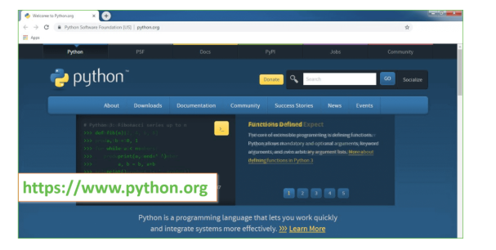

Now, check for the latest and the correct version for your operating system.

**Step 2:** Click on the Download Tab.

**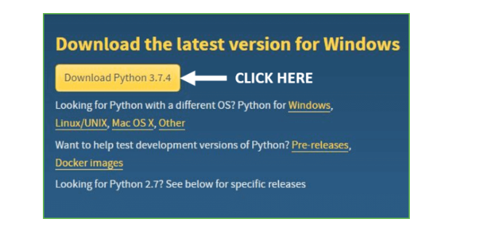**

**Step 3:** You can either select the Download Python for windows 3.7.4 button in Yellow Color or you can scroll further down and click on download with respective to their version. Here, we are downloading the most recent python version for windows 3.7.4

**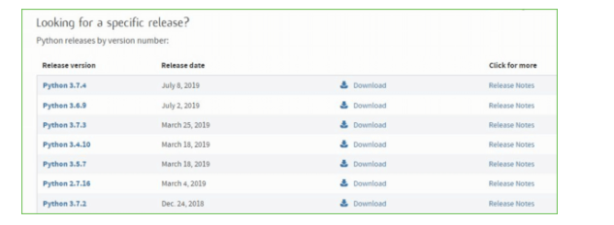**

**Step 4:** Scroll down the page until you find the Files option.

**Step 5:** Here you see a different version of python along with the operating system.

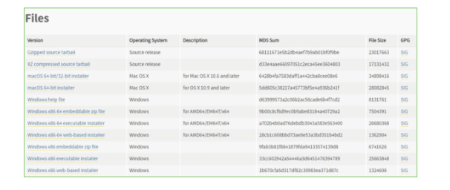

• To download Windows 32-bit python, you can select any one from the three options: Windows x86 embeddable zip file, Windows x86 executable installer or Windows x86 web-based installer.

•To download Windows 64-bit python, you can select any one from the three options: Windows x86-64 embeddable zip file, Windows x86-64 executable installer or Windows x86-64 web-based installer.

Here we will install Windows x86-64 web-based installer. Here your first part regarding which version of python is to be downloaded is completed. Now we move ahead with the second part in installing python i.e. Installation

**Note:** To know the changes or updates that are made in the version you can click on the Release Note Option.

### Installation of Python

**Step 1:** Go to Download and Open the downloaded python version to carry out the installation process.

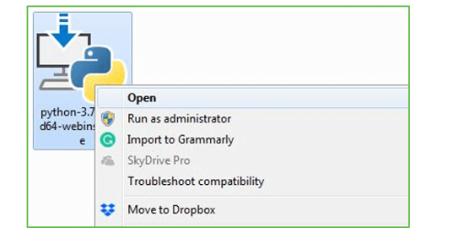

**Step 2:** Before you click on Install Now, Make sure to put a tick on Add Python 3.7 to PATH.

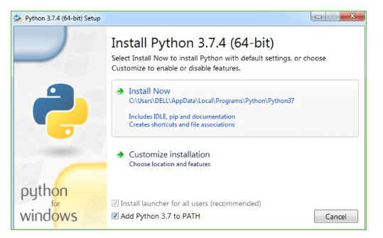

**Step 3:** Click on Install NOW After the installation is successful. Click on Close.

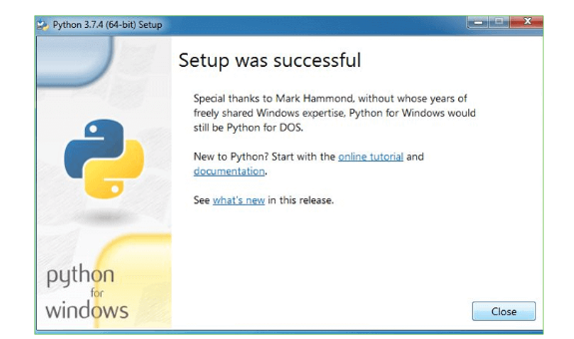

With these above three steps on python installation, you have successfully and correctly installed Python. Now is the time to verify the installation.

**Note:** The installation process might take a couple of minutes.

### Verify the Python Installation

**Step 1:** Click on Start

**Step 2:** In the Windows Run Command, type “cmd”.

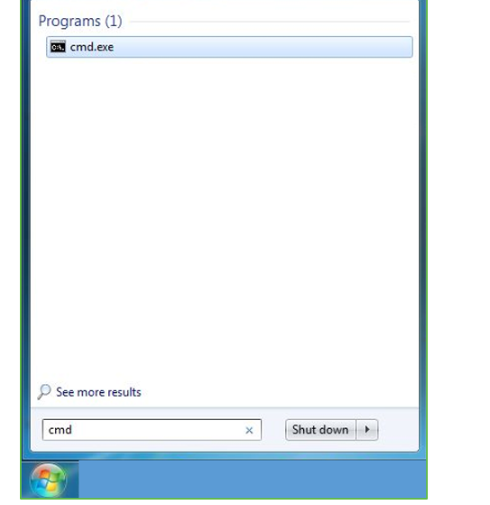

**Step 3:** Open the Command prompt option.

**Step 4:** Let us test whether the python is correctly installed. Type **python –V** and press Enter.

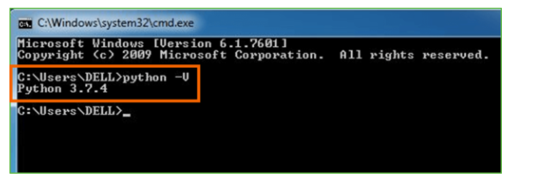

**Step 5:** You will get the answer as 3.7.4

**Note:** If you have any of the earlier versions of Python already installed. You must first uninstall the earlier version and then install the new one.

### Check how the Python IDLE works

**Step 1:** Click on Start

**Step 2:** In the Windows Run command, type “python idle”.

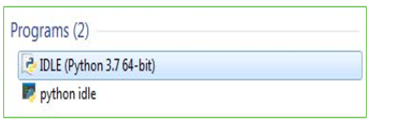

**Step 3:** Click on IDLE (Python 3.7 64-bit) and launch the program

**Step 4:** To go ahead with working in IDLE you must first save the file. **Click on File > Click on Save**

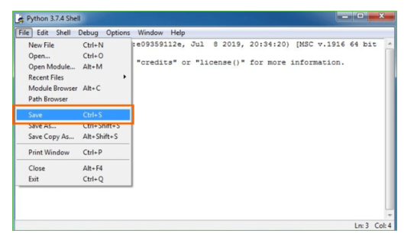

**Step 5:** Name the file and save as type should be Python files. Click on SAVE. Here I have named the files as Hey World.

**Step 6:** Now for e.g. **enter print**

**6.SYSTEM TEST**

The purpose of testing is to discover errors. Testing is the process of trying to discover every conceivable fault or weakness in a work product. It provides a way to check the functionality of components, sub assemblies, assemblies and/or a finished product It is the process of exercising software with the intent of ensuring that the Software system meets its requirements and user expectations and does not fail in an unacceptable manner. There are various types of test. Each test type addresses a specific testing requirement.

### **TYPES OF TESTS**

Unit testing

Unit testing involves the design of test cases that validate that the internal program logic is functioning properly, and that program inputs produce valid outputs. All decision branches and internal code flow should be validated. It is the testing of individual software units of the application .it is done after the completion of an individual unit before integration. This is a structural testing, that relies on knowledge of its construction and is invasive. Unit tests perform basic tests at component level and test a specific business process, application, and/or system configuration. Unit tests ensure that each unique path of a business process performs accurately to the documented specifications and contains clearly defined inputs and expected results.

Integration testing

Integration tests are designed to test integrated software components to determine if they actually run as one program. Testing is event driven and is more concerned with the basic outcome of screens or fields. Integration tests demonstrate that although the components were individually satisfaction, as shown by successfully unit testing, the combination of components is correct and consistent. Integration testing is specifically aimed at exposing the problems that arise from the combination of components.

Functional test

Functional tests provide systematic demonstrations that functions tested are available as specified by the business and technical requirements, system documentation, and user manuals.

Functional testing is centered on the following items:

Valid Input : identified classes of valid input must be accepted.

Invalid Input : identified classes of invalid input must be rejected.

Functions : identified functions must be exercised.

Output : identified classes of application outputs must be exercised.

Systems/Procedures : interfacing systems or procedures must be invoked.

Organization and preparation of functional tests is focused on requirements, key functions, or special test cases. In addition, systematic coverage pertaining to identify Business process flows; data fields, predefined processes, and successive processes must be considered for testing. Before functional testing is complete, additional tests are identified and the effective value of current tests is determined.

System Test

System testing ensures that the entire integrated software system meets requirements. It tests a configuration to ensure known and predictable results. An example of system testing is the configuration oriented system integration test. System testing is based on process descriptions and flows, emphasizing pre-driven process links and integration points.

White Box Testing

White Box Testing is a testing in which in which the software tester has knowledge of the inner workings, structure and language of the software, or at least its purpose. It is purpose. It is used to test areas that cannot be reached from a black box level.

Black Box Testing

Black Box Testing is testing the software without any knowledge of the inner workings, structure or language of the module being tested. Black box tests, as most other kinds of tests, must be written from a definitive source document, such as specification or requirements document, such as specification or requirements document. It is a testing in which the software under test is treated, as a black box .you cannot “see” into it. The test provides inputs and responds to outputs without considering how the software works.

**Unit Testing**

Unit testing is usually conducted as part of a combined code and unit test phase of the software lifecycle, although it is not uncommon for coding and unit testing to be conducted as two distinct phases.

**Test strategy and approach**

Field testing will be performed manually and functional tests will be written in detail.

**Test objectives**

* All field entries must work properly.
* Pages must be activated from the identified link.
* The entry screen, messages and responses must not be delayed.

**Features to be tested**

* Verify that the entries are of the correct format
* No duplicate entries should be allowed
* All links should take the user to the correct page.

# Integration Testing

Software integration testing is the incremental integration testing of two or more integrated software components on a single platform to produce failures caused by interface defects.

The task of the integration test is to check that components or software applications, e.g. components in a software system or – one step up – software applications at the company level – interact without error.

**Test Results:** All the test cases mentioned above passed successfully. No defects encountered.

Acceptance Testing

User Acceptance Testing is a critical phase of any project and requires significant participation by the end user. It also ensures that the system meets the functional requirements.

**Test Results:** All the test cases mentioned above passed successfully. No defects encountered.

**7.SCREENSHOTS**

To run project double click on ‘run.bat’ file to get below screen

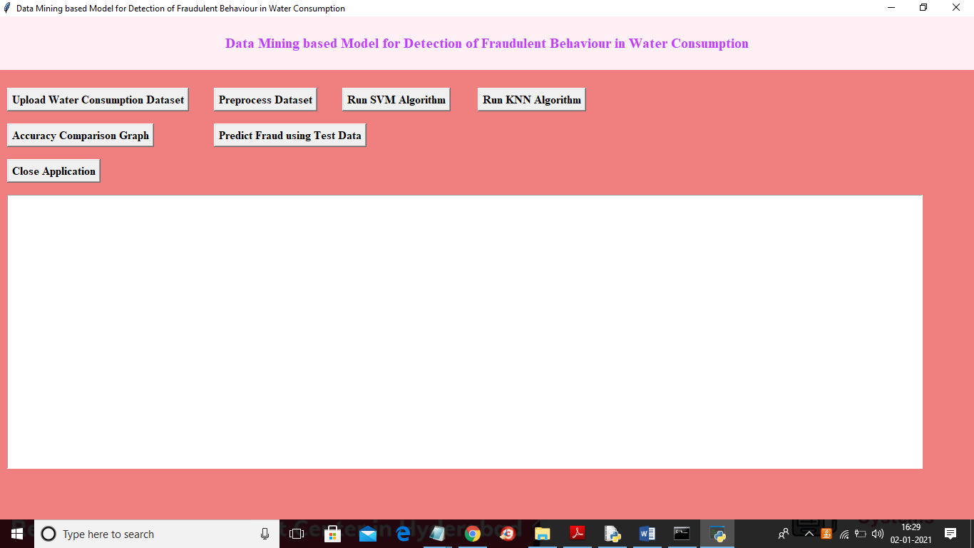

In above screen click on ‘Upload Water Consumption Dataset’ button and upload dataset

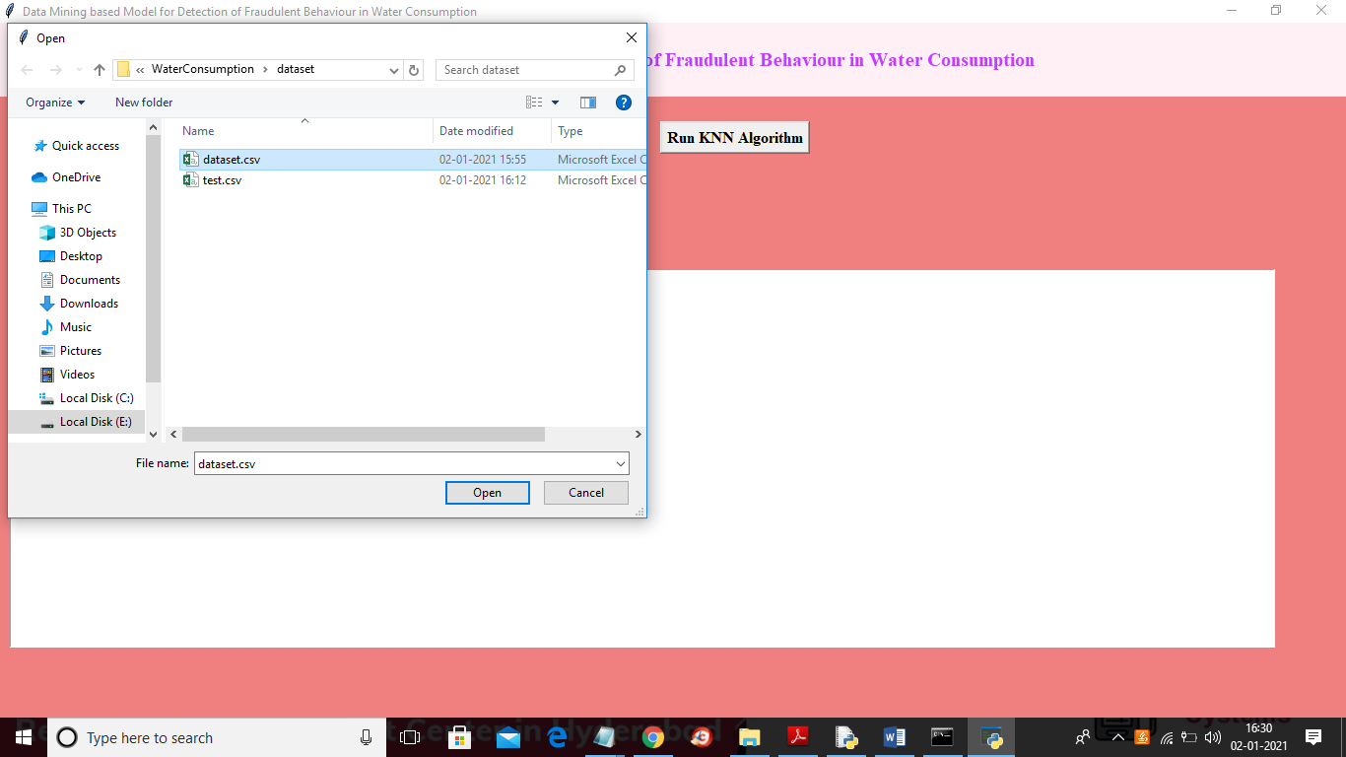

In above screen selecting and uploading ‘dataset.csv’ file and then click on ‘Open’ button to load dataset and to get below screen

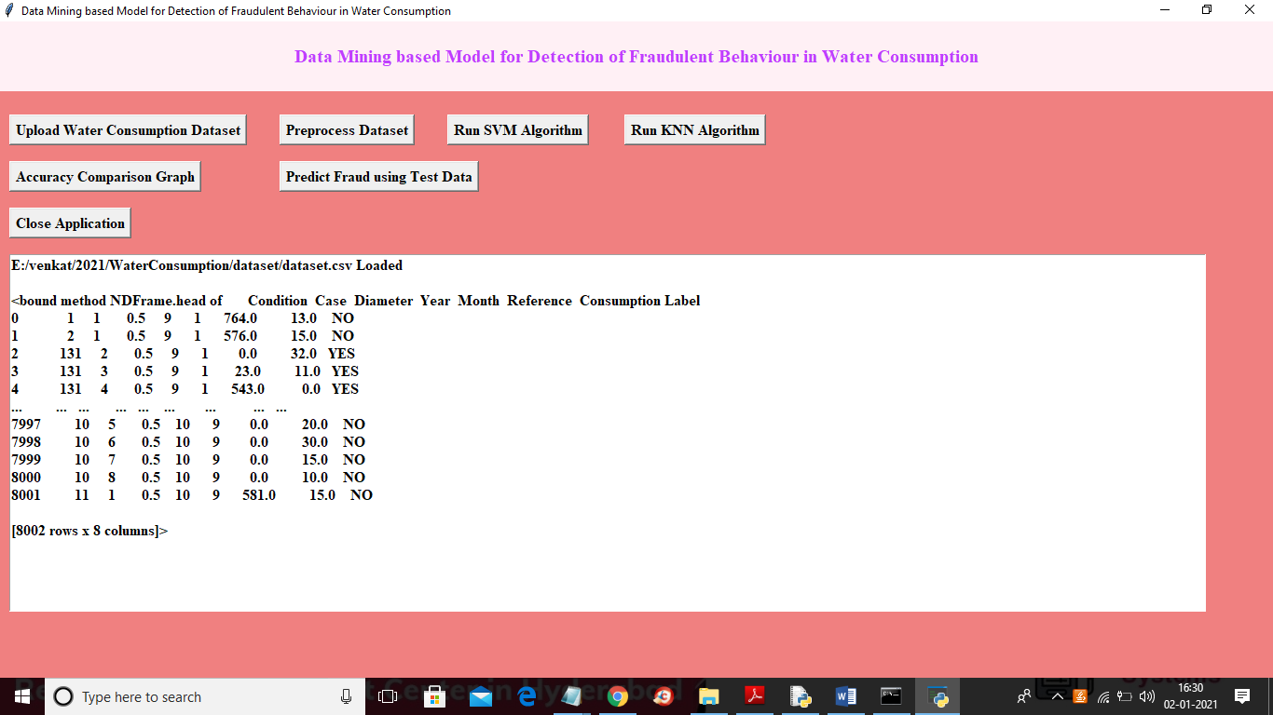

In above screen we can see some records are displaying from dataset and in last column we have string values as YES or NO but SVM or KNN only accept numeric values so we need to apply preprocessing to convert string to numeric data and then apply MINMAX scaler to convert all values between 0 and 1 and then remove all missing and imbalance values and to pre-process click on ‘Preprocess Dataset’ button and to get below screen

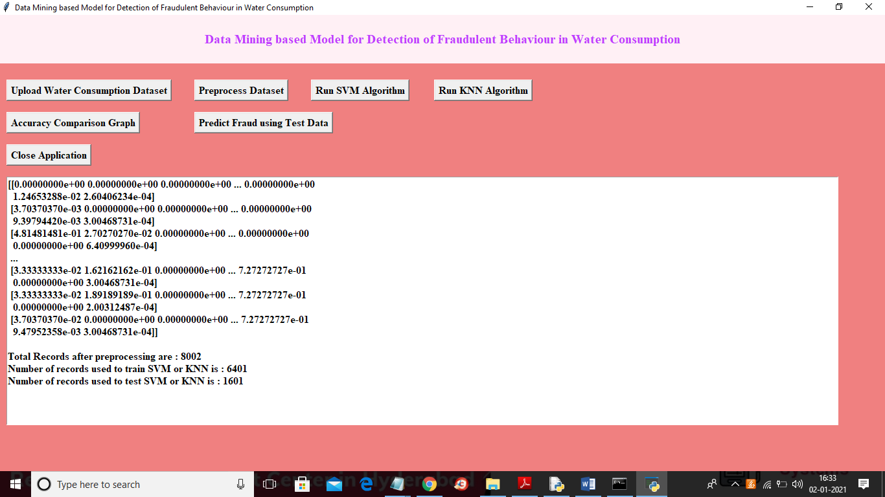

In above screen all values converted to numeric values and then dataset contains total 8002 records and then application using 6401 records to train algorithms and 1601 records to test algorithms prediction accuracy. Now both train and test data is ready and now click on ‘Run SVM Algorithm’ button to apply SVM on train and test data to get accuracy

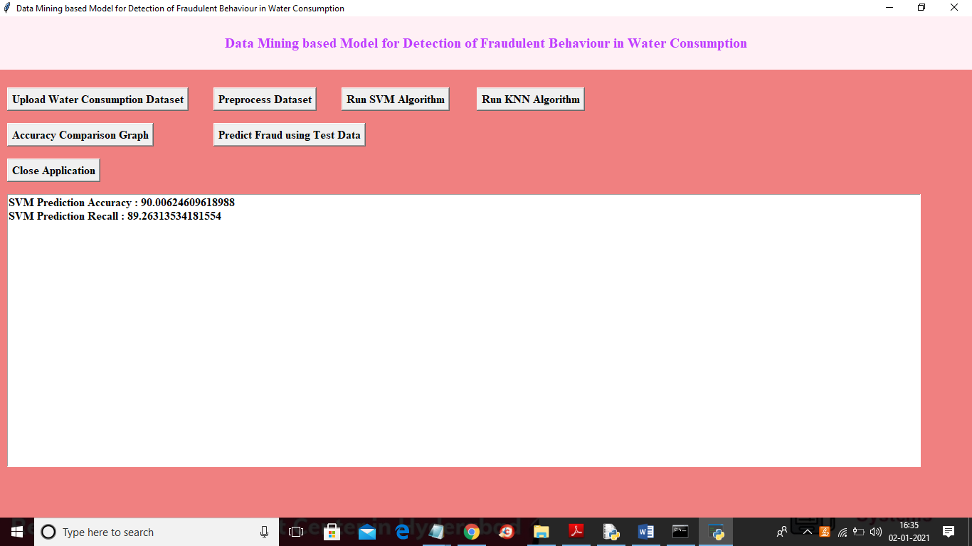

In above screen we got SVM accuracy as 90% and recall as 89% and now click on ‘Run KNN Algorithm’ button to apply train and test data on KNN to get its accuracy

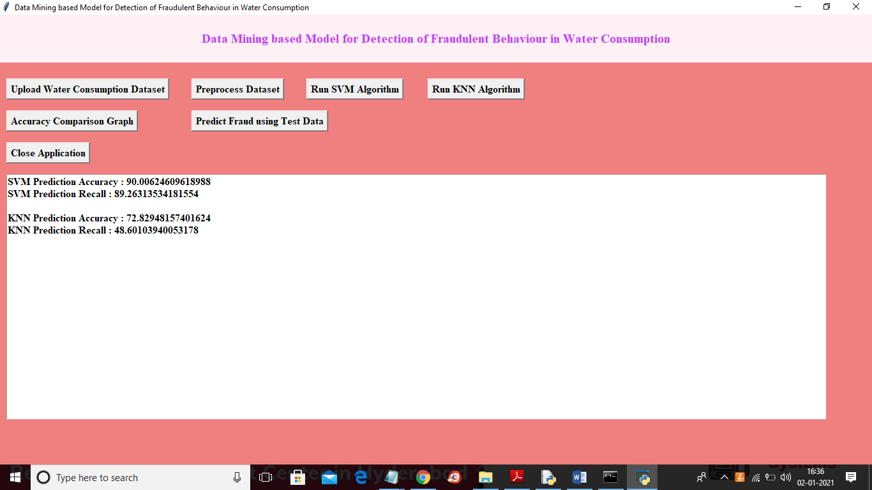

In above screen KNN got 72% accuracy and SVM is better than KNN and now both algorithms trained model is ready and now click on ‘Accuracy Comparison Graph’ button to get below graph

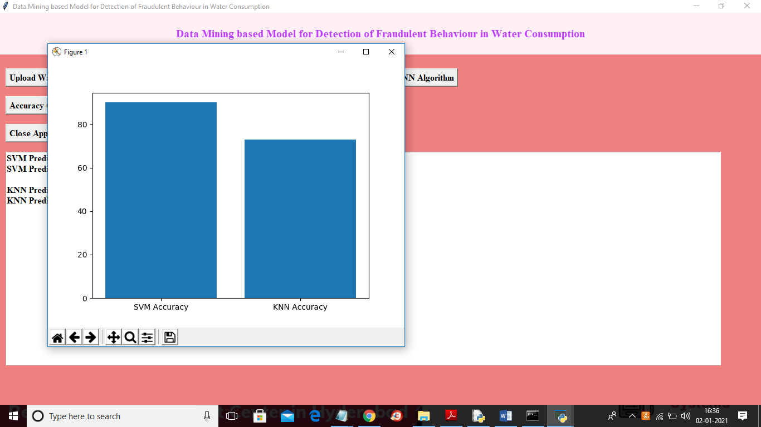

In above screen x-axis represents algorithm name and y-axis represents accuracy of those algorithms and from above graph we can conclude that SVM is better than KNN and now click on ‘Predict Fraud using Test Data’ button to upload test data and predict fraud from that test data

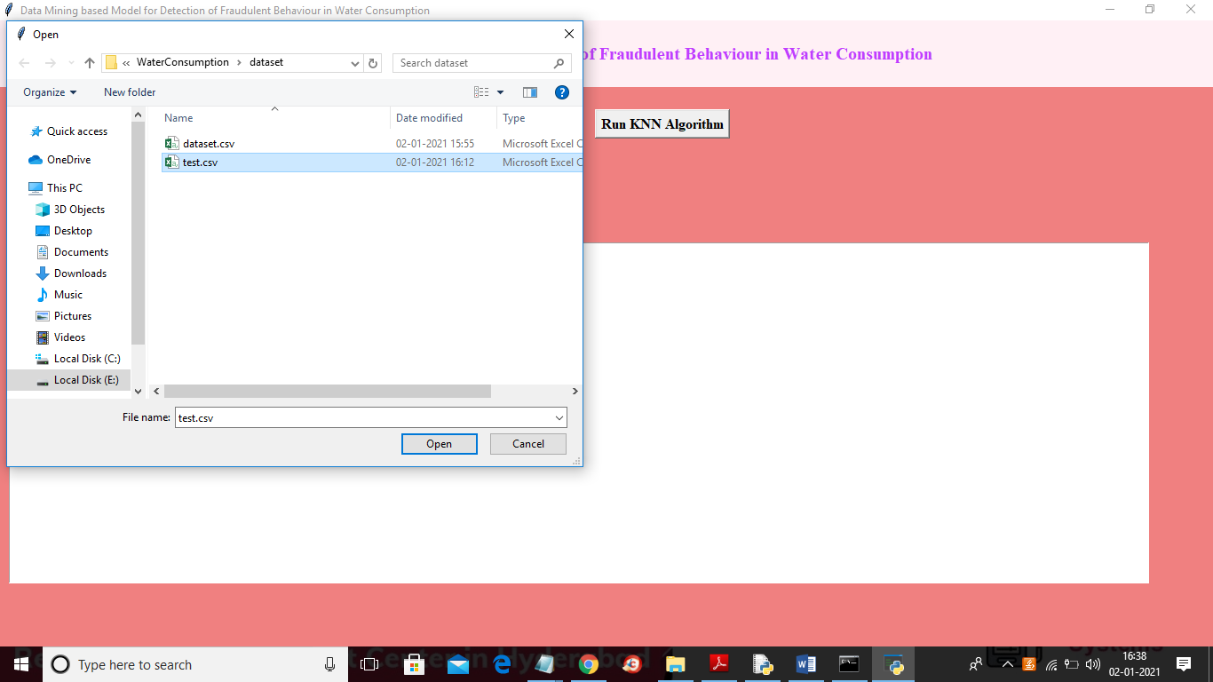

In above screen selecting and uploading ‘test.csv’ file and then click on ‘Open’ button to get below prediction result

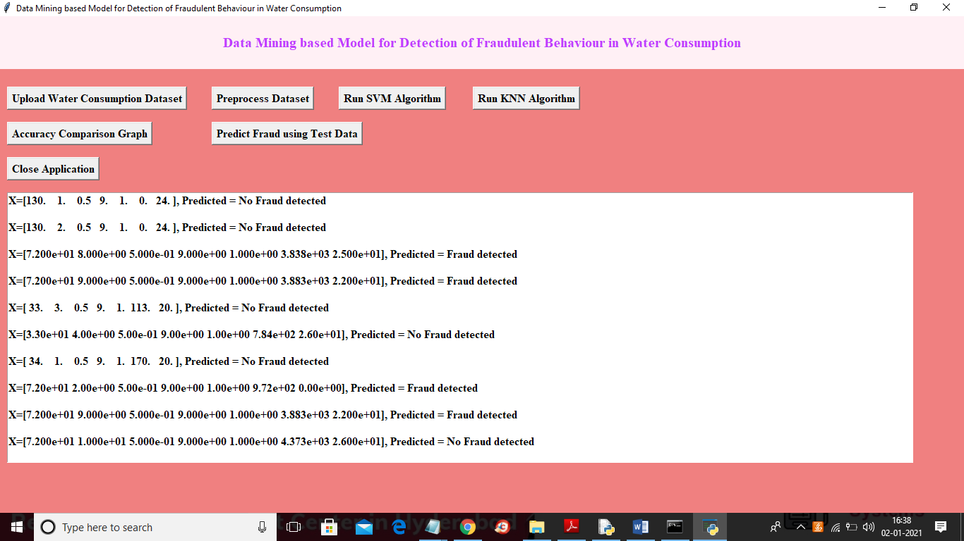

In above screen in brackets we can see uploaded test data and then after bracket we can see prediction result as ‘No Fraud detected’ or ‘Fraud detected’. Similarly u can upload any test data and predict as fraud or no fraud

**8.CONCLUSION**

In this research, we applied the data mining classification techniques for the purpose of detecting customers’ with fraud behaviour in water consumption. We used SVM and KNN classifiers to build classification models for detecting suspicious fraud customers. The models were built using the customers’ historical metered consumption data; the Cross Industry Standard Process for Data Mining (CRISP-DM). The data used in this research study the data was collected from Yarmouk Water Company (YWC) for Qasabat Irbid ROU customers, the data covers five years customers’ water consumptions with 1.5 million customer historical records for 90 thousand customers. This phase took a considerable effort and time to pre-process and format the data to fit the SVM and KNN data mining classifiers. The conducted experiments showed that a good performance of Support Vector Machines (SVM) and K-Nearest Neighbours (KNN) had been achieved with overall accuracy around 70% for both. The model hit rate is 60%-70% which is apparently better than random manual inspections held by YWC teams with hit rate around 1% in identifying fraud customers. This model introduces an intelligent tool that can be used by YWC to detect fraud customers and reduce their profit losses. The suggested model helps saving time and effort of employees of Yarmouk water by identifying billing errors and corrupted meters. With the use of the proposed model, the water utilities can increase cost recovery by reducing administrative Non-Technical Losses (NTL’s) and increasing the productivity of inspection staff by onsite inspections of suspicious fraud customers.

**FUTUREWORK**

The conducted experiments showed that a good performance of Support Vector Machines (SVM) and K-Nearest Neighbors (KNN) had been achieved with overall accuracy around 70% for both. In Future accuracy of the same can be improved with the help of improved techniques. The model hit rate is 60%-70% which is apparently better than random manual inspections held by YWC teams with hit rate around 1% in identifying fraud customers. This model introduces an intelligent tool that can be used by YWC to detect fraud customers and reduce their profit losses. The suggested model helps saving time and effort of employees of Yarmouk water by identifying billing errors and corrupted meters. With the use of the proposed model, the water utilities can increase cost recovery by reducing administrative Non-Technical Losses (NTL’s) and increasing the productivity of inspection staff by onsite inspections of suspicious fraud customers.

**9.REFERENCES**

[1] N/A, “Jordan Water Sector Facts & Figures, Ministry of Water and irrigation of Jordan”. Technical Report. 2015. [2] N/A, “Water Reallocation Policy, Ministry of Water and irrigation of Jordan”. Technical Report. 2016. [3] C. Ramos , A. Souza , J. Papa and A. Falcao, “Fast non-technical losses identification through optimum-path forest”. In Proc. of the 15th Int. Conf. Intelligent System Applications to Power Systems, 2009, pp.1-5. [4] E. Kirkos, C. Spathis and Y. Manolopoulos, “Data mining techniques for the detection of fraudulent financial statements”, Expert Systems with Applications, 32(2007): 995–1003. [5] Y. Sahin and E. Duman, “Detecting credit card fraud by decision trees and support vector machines”, IMECS, 2011, Vol I, pp. 16 – 18. [6] S. Panigrahi, A. Kundu, S. Sural and A. Majumdar, “Credit card fraud detection: a fusion approach using dempster–shafer theory and bayesian learning, information fusion”, 2009, 10(4): 354–363. [7] N. Carneiro, G. Figueira and Costa M., “A data mining based system for credit-card fraud detection in e-tail decision support systems”, Decision Support Systems, 2017, 95(C): 91-101. [8] Ortega P., Figueroa C., and Ruz G. “A Medical Claim Fraud/Abuse Detection System based on Data Mining: A Case Study in Chile”, In proc of DMIN, 2006. [9] B. Kusaksizoglu, “Fraud detection in mobile communication networks using data mining”, Bahcesehir University, The Department of computer engineering, Master Thesis. 2006. [10] C. Liang-Chun, H. Chien-Lung, L.Nai-Wei, Y. Kuo-Hui and L. PingHsien, “Fraud analysis and detection for real-time messaging communications on social networks”, IEICE Trans. Inf. & Syst., 2017, Vol. E100–D, No.10, pp: 2267-2274. [11] J. Nagi, K. Yap, S. Tiong, S. Ahmed and A. Mohammad. “Detection of abnormalities and electricity theft using genetic support vector machines”, In Proc. IEEE TENCON Region 10 Conf., 2008, pp.1-6. [12] J. Nagi, Mohammad A., Yap K., Tiong S., Ahmed S. “Non-Technical Loss Analysis For Detection Of Electricity Theft Using Support Vector Machines”, In Proc IEEE 2nd International Power and Energy Conference, 2008, pp. 907-912. [13] J. Nagi, K. Yap, S. Tiong., S. Ahmed, M. Mohamad. “Nontechnical loss detection for metered customers”, IEEE Transactions on Power Delivery, 2010, 25(2): 1162-1171. [14] C. León, F. Biscarri, I. Monedero, J. Guerrero, J. Biscarri and R. Millán, “Variability and trend-based generalized rule induction model to ntl detection”, IEEE Transactions on Power Systems, 2011, 26(4):1798 - 1807. [15] J. Filho, E. Gontijio, A. Delaiba, E. Mazina., J. Cabral, J and Pinto. “Fraud identification in electricity company customers using decision tree”, Systems, Man and Cybernetics, IEEE International Conference, 2004, 4: 3730 – 3734. [16] R. Jiang, H. Tagiris, A. Lachsz. and M. Jeffrey “Wavelet-based features extraction and multiple classifiers for electricity fraud detection”, In Proc. IEEE/PES Transmission and Distribution Conf. Exhibit. 2002. [17] J. Cabral, J. Pinto. E. Martins and A. Pinto, “Fraud detection in high voltage electricity consumers”. 2008. [18] R. De Faria, K. Ono Fonseca, B. Schneider and S. Nguang, “Collusion and fraud detection on electronic energy meters - a use case of forensics investigation procedures”, in 2014 IEEE Security and Privacy Workshops, pp. 65-68. [19] J. Viegas, P. Esteves, R. Melicio, V. Mendes and S. Vieira, “Solutions for detection of non-technical losses in the electricity grid: a review”, Renewable and Sustainable Energy Reviews, 2017, 80: 1256-1268. [20] B. Coma-Puig, J. Carmona, R. Gavald, S. Alcoverro, and V. Martin, “Fraud detection in energy consumption: a supervised approach”. In Proc IEEE Intl. Conf. on DSAA, 2016, pp. 120-129.